**I/O Structure**

Storage is only one of many types of I/O devices within a computer. A large portion of operating system code is dedicated to managing I/O, both because of its importance to the reliability and performance of a system and because of the varying nature of the devices. Next, we provide an overview of I/O.

A general-purpose computer system consists of CPUs and multiple device controllers that are connected through a common bus. Each device controller is in charge of a specific type of device. Depending on the controller, more than one device may be attached. For instance, seven or more devices can be attached to the small computer-systems interface (SCSI) controller. A device controller maintains some local buffer storage and a set of special-purpose registers. The device controller is responsible for moving the data between the peripheral devices that it controls and its local buffer storage. Typically, operating systems have a device driver for each device controller. This device driver understands the device controller and provides the rest of the operating system with a uniform interface to the device.

To start an I/O operation, the device driver loads the appropriate registers within the device controller. The device controller, in turn, examines the contents of these registers to determine what action to take (such as “read a character from the keyboard”). The controller starts the transfer of data from the device to its local buffer. Once the transfer of data is complete, the device controller informs the device driver via an interrupt that it has finished its operation. The device driver then returns control to the operating system, possibly returning the data or a pointer to the data if the operation was a read. For other operations, the device driver returns status information.

**Storage Structure**

The CPU can load instructions only from memory, so any programs to run must be stored there. General-purpose computers run most of their programs from rewritable memory, called main memory (also called random-access memory, or RAM). Main memory commonly is implemented in a semiconductor technology called dynamic random-access memory (DRAM).

Computers use other forms of memory as well. We have already mentioned read-only memory, ROM) and electrically erasable programmable read-only memory, EEPROM). Because ROM cannot be changed, only static programs, such as the bootstrap program described earlier, are stored there. The immutability of ROM is of use in game cartridges. EEPROM can be changed but cannot be changed frequently and so contains mostly static programs. For example, smartphones have EEPROM to store their factory-installed programs.

All forms of memory provide an array of bytes. Each byte has its own address. Interaction is achieved through a sequence of load or store instructions to specific memory addresses. The load instruction moves a byte or word from main memory to an internal register within the CPU, whereas the store instruction moves the content of a register to main memory. Aside from explicit loads and stores, the CPU automatically loads instructions from main memory for execution.

A typical instruction–execution cycle, as executed on a system with a von Neumann architecture, first fetches an instruction from memory and stores that instruction in the instruction register. The instruction is then decoded and may cause operands to be fetched from memory and stored in some internal register. After the instruction on the operands has been executed, the result may be stored back in memory. Notice that the memory unit sees only a stream of memory addresses. It does not know how they are generated (by the instruction counter, indexing, indirection, literal addresses, or some other means) or what they are for (instructions or data). Accordingly, we can ignore how a memory address is generated by a program. We are interested only in the sequence of memory addresses generated by the running program.

Ideally, we want the programs and data to reside in main memory permanently. This arrangement usually is not possible for the following two reasons:

1. Main memory is usually too small to store all needed programs and data permanently.

2. Main memory is a volatile storage device that loses its contents when power is turned off or otherwise lost.

Thus, most computer systems provide secondary storage as an extension of main memory. The main requirement for secondary storage is that it will be able to hold large quantities of data permanently.

The most common secondary-storage device is a magnetic disk, which provides storage for both programs and data. Most programs (system and application) are stored on a disk until they are loaded into memory. Many programs then use the disk as both the source and the destination of their processing. Hence, the proper management of disk storage is of central importance to a computer system.

In a larger sense, however, the storage structure that we have described— consisting of registers, main memory, and magnetic disks—is only one of many possible storage systems. Others include cache memory, CD-ROM, magnetic tapes, and so on. Each storage system provides the basic functions of storing a datum and holding that datum until it is retrieved at a later time. The main differences among the various storage systems lie in speed, cost, size, and volatility.

The wide variety of storage systems can be organized in a hierarchy (Figure 1.4) according to speed and cost. The higher levels are expensive, but they are fast. As we move down the hierarchy, the cost per bit generally decreases, whereas the access time generally increases. This trade-off is reasonable; if a given storage system were both faster and less expensive than another—other properties being the same—then there would be no reason to use the slower, more expensive memory. In fact, many early storage devices, including paper tape and core memories, are relegated to museums now that magnetic tape and semiconductor memory have become faster and cheaper. The top four levels of memory in Figure 1.4 may be constructed using semiconductor memory.

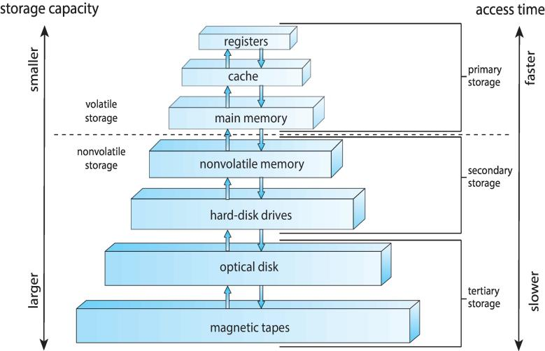

Figure 1.4 Storage-device hierarchy.

In addition to differing in speed and cost, the various storage systems are either volatile or nonvolatile. As mentioned earlier, volatile storage loses its contents when the power to the device is removed. In the absence of expensive battery and generator backup systems, data must be written to nonvolatile storage for safekeeping. In the hierarchy shown in Figure 1.4, the storage systems above the solid-state disk are volatile, whereas those including the solid-state disk and below are nonvolatile.

Solid-state disks have several variants but in general are faster than magnetic disks and are nonvolatile. One type of solid-state disk stores data in a large DRAM array during normal operation but also contains a hidden magnetic hard disk and a battery for backup power. If external power is interrupted, this solid-state disk’s controller copies the data from RAM to the magnetic disk. When external power is restored, the controller copies the data back into RAM. Another form of solid-state disk is flash memory, which is popular in cameras and personal digital assistants (PDAs), in robots, and increasingly for storage on general-purpose computers. Flash memory is slower than DRAM but needs no power to retain its contents. Another form of nonvolatile storage is NVRAM, which is DRAM with battery backup power. This memory can be as fast as DRAM and (as long as the battery lasts) is nonvolatile.

The design of a complete memory system must balance all the factors just discussed: it must use only as much expensive memory as necessary while providing as much inexpensive, nonvolatile memory as possible. Caches can be installed to improve performance where a large disparity in access time or transfer rate exists between two components.

**Direct Memory Access Structure**

Interrupt-driven I/O is fine for moving small amounts of data but can produce high overhead when used for bulk data movement such as disk I/O. To solve this problem, direct memory access (DMA) is used. After setting up buffers, pointers, and counters for the I/O device, the device controller transfers an entire block of data directly to or from its own buffer storage to memory, with no intervention by the CPU. Only one interrupt is generated per block, to tell the device driver that the operation has completed, rather than the one interrupt per byte generated for low-speed devices. While the device controller is performing these operations, the CPU is available to accomplish other work.

Some high-end systems use switch rather than bus architecture. On these systems, multiple components can talk to other components concurrently, rather than competing for cycles on a shared bus. In this case, DMA is even more effective.

**Computer-System Architecture**

A computer system can be organized in a number of different ways, which we can categorize roughly according to the number of general-purpose processors used.

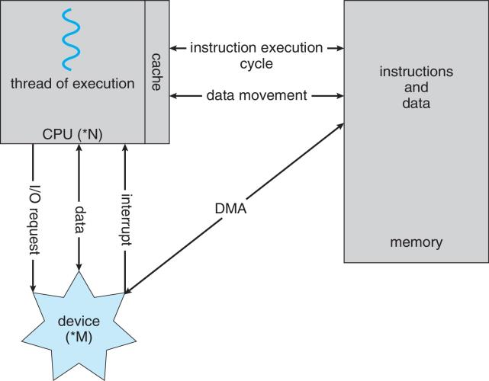

Figure 1.5 How a modern computer system works.

**Single-Processor Systems**

Until recently, most computer systems used a single processor. On a single processor system, there is one main CPU capable of executing a general-purpose instruction set, including instructions from user processes. Almost all single processor systems have other special-purpose processors as well. They may come in the form of device-specific processors, such as disk, keyboard, and graphics controllers; or, on mainframes, they may come in the form of more general-purpose processors, such as I/O processors that move data rapidly among the components of the system.

All of these special-purpose processors run a limited instruction set and do not run user processes. Sometimes, they are managed by the operating system, in that the operating system sends them information about their next task and monitors their status. For example, a disk-controller microprocessor receives a sequence of requests from the main CPU and implements its own disk queue and scheduling algorithm. This arrangement relieves the main CPU of the overhead of disk scheduling. PCs contain a microprocessor in the keyboard to convert the keystrokes into codes to be sent to the CPU. In other systems or circumstances, special-purpose processors are low-level components built into the hardware. The operating system cannot communicate with these processors; they do their jobs autonomously. The use of special-purpose microprocessors is common and does not turn a single-processor system into a multiprocessor. If there is only one general-purpose CPU, then the system is a single-processor system.

**Multiprocessor Systems**

Within the past several years, multiprocessor systems (also known as parallel systems or multicore systems) have begun to dominate the landscape of computing. Such systems have two or more processors in close communication, sharing the computer bus and sometimes the clock, memory, and peripheral devices. Multiprocessor systems first appeared prominently appeared in servers and have since migrated to desktop and laptop systems. Recently, multiple processors have appeared on mobile devices such as smartphones and tablet computers.

Multiprocessor systems have three main advantages:

**1.** **Increased throughput**. By increasing the number of processors, we expect to get more work done in less time. The speed-up ratio with N processors is not N, however; rather, it is less than N. When multiple processors cooperate on a task, a certain amount of overhead is incurred in keeping all the parts working correctly. This overhead, plus contention for shared resources, lowers the expected gain from additional processors. Similarly, N programmers working closely together do not produce N times the amount of work a single programmer would produce.

**2.** **Economy of scale**. Multiprocessor systems can cost less than equivalent multiple single-processor systems, because they can share peripherals, mass storage, and power supplies. If several programs operate on the same set of data, it is cheaper to store those data on one disk and to have all the processors share them than to have many computers with local disks and many copies of the data.

**3.** **Increased reliability**. If functions can be distributed properly among several processors, then the failure of one processor will not halt the system, only slow it down. If we have ten processors and one fails, then each of the remaining nine processors can pick up a share of the work of the failed processor. Thus, the entire system runs only 10 percent slower, rather than failing altogether.

Increased reliability of a computer system is crucial in many applications. The ability to continue providing service proportional to the level of surviving hardware is called graceful degradation. Some systems go beyond graceful degradation and are called fault tolerant, because they can suffer a failure of any single component and still continue operation. Fault tolerance requires a mechanism to allow the failure to be detected, diagnosed, and, if possible, corrected. The HP NonStop (formerly Tandem) system uses both hardware and software duplication to ensure continued operation despite faults. The system consists of multiple pairs of CPUs, working in lockstep. Both processors in the pair execute each instruction and compare the results. If the results differ, then one CPU of the pair is at fault, and both are halted. The process that was being executed is then moved to another pair of CPUs, and the instruction that failed is restarted. This solution is expensive, since it involves special hardware and considerable hardware duplication.

The multiple-processor systems in use today are of two types. Some systems use asymmetric multiprocessing, in which each processor is assigned a specific task. A boss processor controls the system; the other processors either look to the boss for instruction or have predefined tasks. This scheme defines a boss–worker relationship. The boss processor schedules and allocates work to the worker processors.

**Symmetric Multiprocessing Architecture**

The most common systems use symmetric multiprocessing (SMP), in which each processor performs all tasks within the operating system. SMP means that all processors are peers; no boss–worker relationship exists between processors. Figure 1.6 illustrates a typical SMP architecture. Notice that each processor has its own set of registers, as well as a private—or local —cache. However, all processors share physical memory. An example of an SMP system is AIX, a commercial version of UNIX designed by IBM. An AIX system can be configured to employ dozens of processors. The benefit of this model is that many processes can run simultaneously—N processes can run if there are N CPUs—without causing performance to deteriorate significantly. However, we must carefully control I/O to ensure that the data reach the appropriate processor. Also, since the CPUs are separate, one may be sitting idle while another is overloaded, resulting in inefficiencies. These inefficiencies can be avoided if the processors share certain data structures. A multiprocessor system of this form will allow processes and resources—such as memory— to be shared dynamically among the various processors and can lower the variance among the processors. Virtually all modern operating systems—including Windows, Mac OS X, and Linux—now provide support for SMP.

The difference between symmetric and asymmetric multiprocessing may result from either hardware or software. Special hardware can differentiate the multiple processors, or the software can be written to allow only one boss and multiple workers. For instance, Sun Microsystems’ operating system SunOS Version 4 provided asymmetric multiprocessing, whereas Version 5 (Solaris) is symmetric on the same hardware.

Multiprocessing adds CPUs to increase computing power. If the CPU has an integrated memory controller, then adding CPUs can also increase the amount of memory addressable in the system. Either way, multiprocessing can cause a system to change its memory access model from uniform memory access (UMA) to non-uniform memory access (NUMA). UMA is defined as the situation in which access to any RAM from any CPU takes the same amount of time. With NUMA, some parts of memory may take longer to access than other parts, creating a performance penalty. Operating systems can minimize the NUMA penalty through resource management.

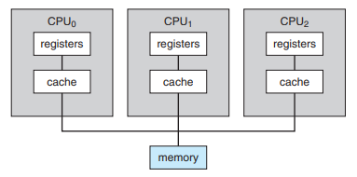

Figure 1.6 Symmetric multiprocessing architecture.

**A Dual-Core Design**

A recent trend in CPU design is to include multiple computing cores on a single chip. Such multiprocessor systems are termed multicore. They can be more efficient than multiple chips with single cores because on-chip communication is faster than between-chip communication. In addition, one chip with multiple cores uses significantly less power than multiple single-core chips.

It is important to note that while multicore systems are multiprocessor systems, not all multiprocessor systems are multicore, as we shall see in Section 1.3.3. In our coverage of multiprocessor systems throughout this text, unless we state otherwise, we generally use the more contemporary term multicore, which excludes some multiprocessor systems.

In Figure 1.7, we show a dual-core design with two cores on the same chip. In this design, each core has its own register set as well as its own local cache. Other designs might use a shared cache or a combination of local and shared caches. Aside from architectural considerations, such as cache, memory, and bus contention, these multicore CPUs appear to the operating system as N standard processors. This characteristic puts pressure on operating system designers—and application programmers—to make use of those processing cores.

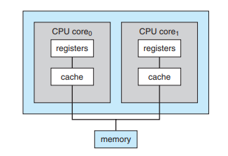

Figure 1.7 A dual-core design with two cores placed on the same chip

**Clustered Systems**

Another type of multiprocessor system is a clustered system, which gathers together multiple CPUs. Clustered systems differ from the multiprocessor systems that they are composed of two or more individual systems—or nodes—joined together. Such systems are considered loosely coupled. Each node may be a single processor system or a multicore system. We should note that the definition of clustered is not concrete; many commercial packages wrestle to define a clustered system and why one form is better than another. The generally accepted definition is that clustered computers share storage and are closely linked via a local-area network LAN or a faster interconnect, such as InfiniBand.

Clustering is usually used to provide high-availability service—that is, service will continue even if one or more systems in the cluster fail. Generally, we obtain high availability by adding a level of redundancy in the system. A layer of cluster software runs on the cluster nodes. Each node can monitor one or more of the others (over the LAN). If the monitored machine fails, the monitoring machine can take ownership of its storage and restart the applications that were running on the failed machine. The users and clients of the applications see only a brief interruption of service.

Clustering can be structured asymmetrically or symmetrically. In asymmetric clustering, one machine is in hot-standby mode while the other is running the applications. The hot-standby host machine does nothing but monitor the active server. If that server fails, the hot-standby host becomes the active server. In symmetric clustering, two or more hosts are running applications and are monitoring each other. This structure is obviously more efficient, as it uses all of the available hardware. However it does require that more than one application be available to run.

Since a cluster consists of several computer systems connected via a network, clusters can also be used to provide high-performance computing environments. Such systems can supply significantly greater computational power than single-processor or even SMP systems because they can run an application concurrently on all computers in the cluster. The application must have been written specifically to take advantage of the cluster, however. This involves a technique known as parallelization, which divides a program into separate components that run in parallel on individual computers in the cluster. Typically, these applications are designed so that once each computing node in the cluster has solved its portion of the problem, the results from all the nodes are combined into a final solution.

Other forms of clusters include parallel clusters and clustering over a wide-area network (WAN). Parallel clusters allow multiple hosts to access the same data on shared storage. Because most operating systems lack support for simultaneous data access by multiple hosts, parallel clusters usually require the use of special versions of software and special releases of applications. For example, Oracle Real Application Cluster is a version of Oracle’s database that has been designed to run on a parallel cluster. Each machine runs Oracle, and a layer of software tracks access to the shared disk. Each machine has full access to all data in the database. To provide this shared access, the system must also supply access control and locking to ensure that no conflicting operations occur. This function, commonly known as a distributed lock manager (DLM), is included in some cluster technology.

Cluster technology is changing rapidly. Some cluster products support dozens of systems in a cluster, as well as clustered nodes that are separated by miles. Many of these improvements are made possible by storage-area networks (SANs), which allow many systems to attach to a pool of storage. If the applications and their data are stored on the SAN, then the cluster software can assign the application to run on any host that is attached to the SAN. If the host fails, then any other host can take over. In a database cluster, dozens of hosts can share the same database, greatly increasing performance and reliability. Figure 1.8 depicts the general structure of a clustered system.

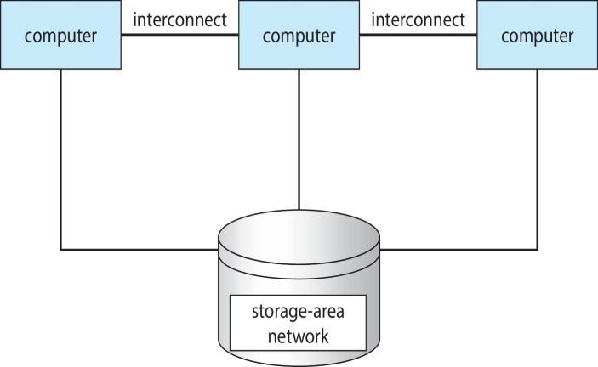

Figure 1.8 General structure of a clustered system

**Operating-System Operations**

As mentioned earlier, modern operating systems are interrupt driven. If there are no processes to execute, no I/O devices to service, and no users to whom to respond, an operating system will sit quietly, waiting for something to happen. Events are almost always signaled by the occurrence of an interrupt or a trap. A trap (or an exception) is a software-generated interrupt caused either by an error (for example, division by zero or invalid memory access) or by a specific request from a user program that an operating-system service be performed. The interrupt-driven nature of an operating system defines that system’s general structure. For each type of interrupt, separate segments of code in the operating system determine what action should be taken. An interrupt service routine is provided to deal with the interrupt.

Since the operating system and the users share the hardware and software resources of the computer system, we need to make sure that an error in a user program could cause problems only for the one program running. With sharing, many processes could be adversely affected by a bug in one program. For example, if a process gets stuck in an infinite loop, this loop could prevent the correct operation of many other processes. More subtle errors can occur in a multiprogramming system, where one erroneous program might modify another program, the data of another program, or even the operating system itself.

Without protection against these sorts of errors, either the computer must execute only one process at a time or all output must be suspect. A properly designed operating system must ensure that an incorrect (or malicious) program cannot cause other programs to execute incorrectly.

**Multi-programming and Multitasking**

One of the most important aspects of operating systems is the ability to multiprogram. A single program cannot, in general, keep either the CPU or the I/O devices busy at all times. Single users frequently have multiple programs running. Multiprogramming increases CPU utilization by organizing jobs (code and data) so that the CPU always has one to execute.

The idea is as follows: The operating system keeps several jobs in memory simultaneously (Figure 1.9). Since, in general, main memory is too small to accommodate all jobs, the jobs are kept initially on the disk in the job pool. This pool consists of all processes residing on disk awaiting allocation of main memory.

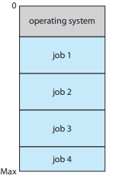

Figure 1.9 Memory layout for a multiprogramming system.

The set of jobs in memory can be a subset of the jobs kept in the job pool. The operating system picks and begins to execute one of the jobs in memory. Eventually, the job may have to wait for some task, such as an I/O operation, to complete. In a non-multiprogrammed system, the CPU would sit idle. In a multiprogrammed system, the operating system simply switches to, and executes, another job. When that job needs to wait, the CPU switches to another job, and so on. Eventually, the first job finishes waiting and gets the CPU back. As long as at least one job needs to execute, the CPU is never idle.

This idea is common in other life situations. A lawyer does not work for only one client at a time, for example. While one case is waiting to go to trial or have papers typed, the lawyer can work on another case. If he has enough clients, the lawyer will never be idle for lack of work. (Idle lawyers tend to become politicians, so there is a certain social value in keeping lawyers busy.)

Multiprogrammed systems provide an environment in which the various system resources (for example, CPU, memory, and peripheral devices) are utilized effectively, but they do not provide for user interaction with the computer system. Time sharing (or multitasking) is a logical extension of multiprogramming. In time-sharing systems, the CPU executes multiple jobs by switching among them, but the switches occur so frequently that the users can interact with each program while it is running.

Time sharing requires an interactive computer system, which provides direct communication between the user and the system. The user gives instructions to the operating system or to a program directly, using a input device such as a keyboard, mouse, touch pad, or touch screen, and waits for immediate results on an output device. Accordingly, the response time should be short—typically less than one second.

A time-shared operating system allows many users to share the computer simultaneously. Since each action or command in a time-shared system tends to be short, only a little CPU time is needed for each user. As the system switches rapidly from one user to the next, each user is given the impression that the entire computer system is dedicated to his use, even though it is being shared among many users.

A time-shared operating system uses CPU scheduling and multiprogramming to provide each user with a small portion of a time-shared computer. Each user has at least one separate program in memory. A program loaded into memory and executing is called a process. When a process executes, it typically executes for only a short time before it either finishes or needs to perform I/O. I/O may be interactive; that is, output goes to a display for the user, and input comes from a user keyboard, mouse, or other device. Since interactive I/O typically runs at “people speeds,” it may take a long time to complete. Input, for example, may be bounded by the user’s typing speed; seven characters per second is fast for people but incredibly slow for computers. Rather than let the CPU sit idle as this interactive input takes place, the operating system will rapidly switch the CPU to the program of some other user.

Time sharing and multiprogramming require that several jobs be kept simultaneously in memory. If several jobs are ready to be brought into memory, and if there is not enough room for all of them, then the system must choose among them. Making this decision involves job scheduling, which we discuss in Chapter 6. When the operating system selects a job from the job pool, it loads that job into memory for execution. Having several programs in memory at the same time requires some form of memory management, which we cover in Chapters 8 and 9. In addition, if several jobs are ready to run at the same time, the system must choose which job will run first. Making this decision is CPU scheduling, which is also discussed in Chapter 6. Finally, running multiple jobs concurrently requires that their ability to affect one another be limited in all phases of the operating system, including process scheduling, disk storage, and memory management. We discuss these considerations throughout the text.

In a time-sharing system, the operating system must ensure reasonable response time. This goal is sometimes accomplished through swapping, whereby processes are swapped in and out of main memory to the disk. A more common method for ensuring reasonable response time is virtual memory, a technique that allows the execution of a process that is not completely in memory. . The main advantage of the virtual-memory scheme is that it enables users to run programs that are larger than actual physical memory. Further, it abstracts main memory into a large, uniform array of storage, separating logical memory as viewed by the user from physical memory. This arrangement frees programmers from concern over memory-storage limitations.

**Dual-mode and Multimode Operation**

In order to ensure the proper execution of the operating system, we must be able to distinguish between the execution of operating-system code and userdefined code. The approach taken by most computer systems is to provide hardware support that allows us to differentiate among various modes of execution.

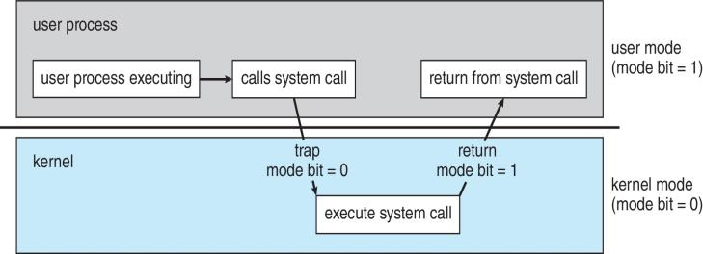

Figure 1.10 Transition from user to kernel mode.

At the very least, we need two separate modes of operation: user mode and kernel mode (also called supervisor mode, system mode, or privileged mode). A bit, called the mode bit, is added to the hardware of the computer to indicate the current mode: kernel (0) or user (1). With the mode bit, we can distinguish between a task that is executed on behalf of the operating system and one that is executed on behalf of the user. When the computer system is executing on behalf of a user application, the system is in user mode. However, when a user application requests a service from the operating system (via a system call), the system must transition from user to kernel mode to fulfill the request. This is shown in Figure 1.10. As we shall see, this architectural enhancement is useful for many other aspects of system operation as well.

At system boot time, the hardware starts in kernel mode. The operating system is then loaded and starts user applications in user mode. Whenever a trap or interrupt occurs, the hardware switches from user mode to kernel mode (that is, changes the state of the mode bit to 0). Thus, whenever the operating system gains control of the computer, it is in kernel mode. The system always switches to user mode (by setting the mode bit to 1) before passing control to a user program.

The dual mode of operation provides us with the means for protecting the operating system from errant users—and errant users from one another. We accomplish this protection by designating some of the machine instructions that may cause harm as privileged instructions. The hardware allows privileged instructions to be executed only in kernel mode. If an attempt is made to execute a privileged instruction in user mode, the hardware does not execute the instruction but rather treats it as illegal and traps it to the operating system.

The instruction to switch to kernel mode is an example of a privileged instruction. Some other examples include I/O control, timer management, and interrupt management. As we shall see throughout the text, there are many additional privileged instructions.

The concept of modes can be extended beyond two modes (in which case the CPU uses more than one bit to set and test the mode). CPUs that support virtualization (Section 16.1) frequently have a separate mode to indicate when the virtual machine manager (VMM)—and the virtualization management software—is in control of the system. In this mode, the VMM has more privileges than user processes but fewer than the kernel. It needs that level of privilege so it can create and manage virtual machines, changing the CPU state to do so. Sometimes, too, different modes are used by various kernel components. We should note that, as an alternative to modes, the CPU designer may use other methods to differentiate operational privileges. The Intel 64 family of CPUs supports four privilege levels, for example, and supports virtualization but does not have a separate mode for virtualization.

We can now see the life cycle of instruction execution in a computer system. Initial control resides in the operating system, where instructions are executed in kernel mode. When control is given to a user application, the mode is set to user mode. Eventually, control is switched back to the operating system via an interrupt, a trap, or a system call.

System calls provide the means for a user program to ask the operating system to perform tasks reserved for the operating system on the user program’s behalf. A system call is invoked in a variety of ways, depending on the functionality provided by the underlying processor. In all forms, it is the method used by a process to request action by the operating system. A system call usually takes the form of a trap to a specific location in the interrupt vector. This trap can be executed by a generic trap instruction, although some systems (such as MIPS) have a specific syscall instruction to invoke a system call.

When a system call is executed, it is typically treated by the hardware as a software interrupt. Control passes through the interrupt vector to a service routine in the operating system, and the mode bit is set to kernel mode. The system-call service routine is a part of the operating system. The kernel examines the interrupting instruction to determine what system call has occurred; a parameter indicates what type of service the user program is requesting. Additional information needed for the request may be passed in registers, on the stack, or in memory (with pointers to the memory locations passed in registers). The kernel verifies that the parameters are correct and legal, executes the request, and returns control to the instruction following the system call.

**Process Management**

A program does nothing unless its instructions are executed by a CPU. A program in execution, as mentioned, is a process. A time-shared user program such as a compiler is a process. A word-processing program being run by an individual user on a PC is a process. A system task, such as sending output to a printer, can also be a process (or at least part of one). For now, you can consider a process to be a job or a time-shared program, but later you will learn that the concept is more general. As we shall see in Chapter 3, it is possible to provide system calls that allow processes to create subprocesses to execute concurrently.

A process needs certain resources—including CPU time, memory, files, and I/O devices—to accomplish its task. These resources are either given to the process when it is created or allocated to it while it is running. In addition to the various physical and logical resources that a process obtains when it is created, various initialization data (input) may be passed along. For example, consider a process whose function is to display the status of a file on the screen of a terminal. The process will be given the name of the file as an input and will execute the appropriate instructions and system calls to obtain and display the desired information on the terminal. When the process terminates, the operating system will reclaim any reusable resources.

We emphasize that a program by itself is not a process. A program is a passive entity, like the contents of a file stored on disk, whereas a process is an active entity. A single-threaded process has one program counter specifying the next instruction to execute. (Threads are covered in Chapter 4.) The execution of such a process must be sequential. The CPU executes one instruction of the process after another, until the process completes. Further, at any time, one instruction at most is executed on behalf of the process. Thus, although two processes may be associated with the same program, they are nevertheless considered two separate execution sequences. A multithreaded process has multiple program counters, each pointing to the next instruction to execute for a given thread.

A process is the unit of work in a system. A system consists of a collection of processes, some of which are operating-system processes (those that execute system code) and the rest of which are user processes (those that execute user code). All these processes can potentially execute concurrently—by multiplexing on a single CPU, for example.

The operating system is responsible for the following activities in connection with process management:

• Scheduling processes and threads on the CPUs

• Creating and deleting both user and system processes

• Suspending and resuming processes

• Providing mechanisms for process synchronization

• Providing mechanisms for process communication

**Memory Management**

The main memory is central to the operation of a modern computer system. Main memory is a large array of bytes, ranging in size from hundreds of thousands to billions. Each byte has its own address. Main memory is a repository of quickly accessible data shared by the CPU and I/O devices. The central processor reads instructions from main memory during the instruction-fetch cycle and both reads and writes data from main memory during the data-fetch cycle (on a von Neumann architecture). As noted earlier, the main memory is generally the only large storage device that the CPU is able to address and access directly. For example, for the CPU to process data from disk, those data must first be transferred to main memory by CPU-generated I/O calls. In the same way, instructions must be in memory for the CPU to execute them.

For a program to be executed, it must be mapped to absolute addresses and loaded into memory. As the program executes, it accesses program instructions and data from memory by generating these absolute addresses. Eventually, the program terminates, its memory space is declared available, and the next program can be loaded and executed.

To improve both the utilization of the CPU and the speed of the computer’s response to its users, general-purpose computers must keep several programs in memory, creating a need for memory management. Many different memory- management schemes are used. These schemes reflect various approaches, and the effectiveness of any given algorithm depends on the situation. In selecting a memory-management scheme for a specific system, we must take into account many factors—especially the hardware design of the system. Each algorithm requires its own hardware support.

The operating system is responsible for the following activities in connection with memory management:

• Keeping track of which parts of memory are currently being used and who is using them

• Deciding which processes (or parts of processes) and data to move into and out of memory

• Allocating and deallocating memory space as needed

**File-system Management**

File management is one of the most visible components of an operating system. Computers can store information on several different types of physical media. Magnetic disk, optical disk, and magnetic tape are the most common. Each of these media has its own characteristics and physical organization. Each medium is controlled by a device, such as a disk drive or tape drive, that also has its own unique characteristics. These properties include access speed, capacity, data-transfer rate, and access method (sequential or random).

A file is a collection of related information defined by its creator. Commonly, files represent programs (both source and object forms) and data. Data files may be numeric, alphabetic, alphanumeric, or binary. Files may be free-form (for example, text files), or they may be formatted rigidly (for example, fixed fields). Clearly, the concept of a file is an extremely general one.

The operating system implements the abstract concept of a file by managing mass-storage media, such as tapes and disks, and the devices that control them. In addition, files are normally organized into directories to make them easier to use. Finally, when multiple users have access to files, it may be desirable to control which user may access a file and how that user may access it (for example, read, write, append).

The operating system is responsible for the following activities in connection with file management:

• Creating and deleting files

• Creating and deleting directories to organize files

• Supporting primitives for manipulating files and directories

• Mapping files onto secondary storage

• Backing up files on stable (nonvolatile) storage media

**Caching**

Caching is an important principle of computer systems. Here’s how it works. Information is normally kept in some storage system (such as main memory). As it is used, it is copied into a faster storage system—the cache—on a temporary basis. When we need a particular piece of information, we first check whether it is in the cache. If it is, we use the information directly from the cache. If it is not, we use the information from the source, putting a copy in the cache under the assumption that we will need it again soon.

In addition, internal programmable registers, such as index registers, provide a high-speed cache for main memory. The programmer (or compiler) implements the register-allocation and register-replacement algorithms to decide which information to keep in registers and which to keep in main memory.

Other caches are implemented totally in hardware. For instance, most systems have an instruction cache to hold the instructions expected to be executed next. Without this cache, the CPU would have to wait several cycles while an instruction was fetched from main memory. For similar reasons, most systems have one or more high-speed data caches in the memory hierarchy. We are not concerned with these hardware-only caches in this text, since they are outside the control of the operating system.

Because caches have limited size, cache management is an important design problem. Careful selection of the cache size and of a replacement policy can result in greatly increased performance.